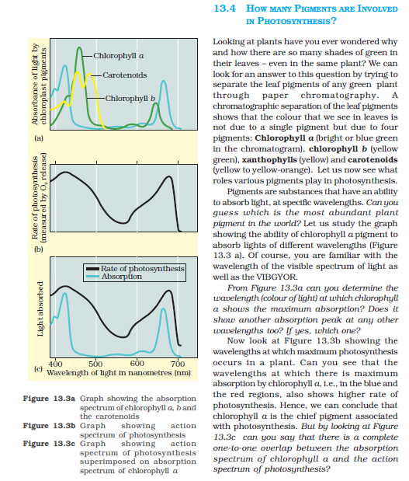

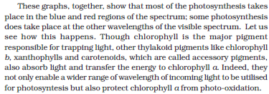

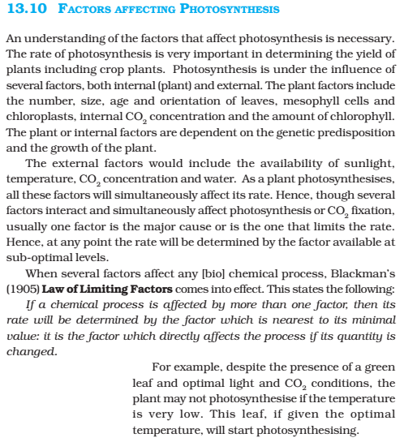

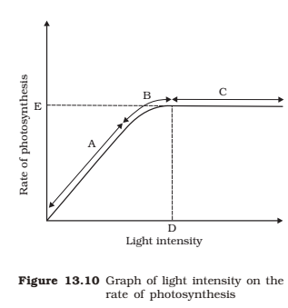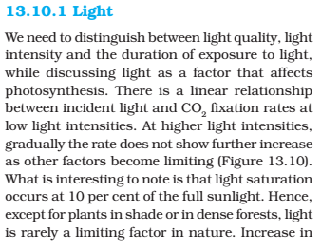

Capture5

Source: CBSE class 11 biology textbook.

LIGHT AS A LIMITING FACTOR

The ultimate source of light for photosynthesis in green plants is solar radiation, which moves in the form of electromagnetic waves. Out of the total solar energy reaching to the earth about 2% is used in photosynthesis and about 10% is used in other metabolic activities. Light varies in intensity , quality and duration.

1. Light Intensity: The total light perceived by a plant depends on its general form (viz ,height, size of leaves etc) and arrangements of leaves. Of the total light falling on the leaf, about 80% is absorbed, 10% is reflected and 10% is transmitted. Under low light intensity usually the rate of photosynthesis is low. Increase in light intensity causes increase in rate of photosynthesis until some other factors become limiting. At very high light intensity beyond a certain point exhibit photosynthetising cells exhibit photo oxidation of its constituents. This phenomenon is called SOLARIZATION. Requirement of light intensities by the plant varies considerably. For eg, certain plants require low light intensity for optimum photosynthesis and low shady habitats. These plants are called SCIOPHYTES. On the other hand, certain plants love intense light and require high light intensity for photosynthesis. Such plants are called HELIOPHYTES. Moreover, light has some indirect effect on photosynthesis. For eg, it affects the opening and closing of stomata. Stomata are closed in low light and open in high light intensity. Closed stomata restricts the entry of (CO2) and reduces the rate of photosynthesis.
2. Light Quality: Photosynthetic pigments absorb the visible part of radiation (380mu to 760mu). For eg, chlorophyll absorbs blue and red light. Usually plants show high rate of photosynthesis in the blue and red light.
3. Duration of light: Longer duration of light periods favors photosynthesis. Generally, if the plants get 10 to 12 hours light per day it favours good photosynthesis. Plants can continuously exhibit photosynthesis under continuous light without being damaged.

How much PAR is received by plants from the sun?

The total irradiance from the sun coming at the upper boundary of the atmosphere is 1360(W/m2).

This irradiance includes uv and ir wavelengths. Of this only 900(W/m2) reach plants because the rest is absorbed or scattered by watervapour, dust, (CO2) and ozone resent in the atmosphere. Of this about half is present in the ir, roughly 5% in the uv region and the rest has wavelengths between 400 to 700nm. Therefore, the plants receive about 400 to 500(W/m2) PAR from the sun.

Can photosynthesis occur under the light of ordinary fluorescent lamps?;

The fluorescent lamps are commonly called tube rods. They produce light by fluorescence which is usually rich in blue and red wavelengths. Therefore, photosynthesis can occur under the light of ordinary fluorescent lamps provided it is about 400 to 500 lux (10.67lux = 1foot-candle)

**For our system:**

**Calculations:**

**Grow bed area= 0.75(m) x 0.30(m) = 0.225(m2)**

**Approximate amount of light required=0.225*450 = 100(W/m2)**

Source: class 11 pradeep’s biology part2.

Grow light

A grow light or plant light is an artificial light source, generally an electric light, designed to stimulate plant growth by emitting an electromagnetic spectrum appropriate for photosynthesis. Grow lights are used in applications where there is either no naturally occurring light, or where supplemental light is required. For example, in the winter months when the available hours of daylight may be insufficient for the desired plant growth, lights are used to extend the time the plants receive light. If plants do not receive enough light, they will grow long and spindly.

Grow lights either attempt to provide a light spectrum similar to that of the sun, or to provide a spectrum that is more tailored to the needs of the plants being cultivated. Outdoor conditions are mimicked with varying colour, temperatures and spectral outputs from the grow light, as well as varying the lumen output (intensity) of the lamps. Depending on the type of plant being cultivated, the stage of cultivation (e.g. the germination/vegetative phase or the flowering/fruiting phase), and the photoperiod required by the plants, specific ranges of spectrum, luminous efficacy and colour temperature are desirable for use with specific plants and time periods.

Russian botanist Andrei Famintsyn was the first to use artificial light for plant growing and research (1868).

Grow lights are used for horticulture, indoor gardening, plant propagation and food production, including indoor hydroponics and aquatic plants. Although most grow lights are used on an industrial level, they can also be used in households.

According to the inverse-square law, the intensity of light radiating from a point source (in this case a bulb) that reaches a surface is inversely proportional to the square of the surface's distance from the source (if an object is twice as far away, it receives only a quarter the light) which is a serious hurdle for indoor growers, and many techniques are employed to use light as efficiently as possible. Reflectors are thus often used in the lights to maximize light efficiency. Plants or lights are moved as close together as possible so that they receive equal lighting and that all light coming from the lights falls on the plants rather than on the surrounding area.

A range of bulb types can be used as grow lights, such as incandescents, fluorescent lights, high-intensity discharge lamps (HID), and light-emitting diodes (LED). Today, the most widely used lights for professional use are HIDs and fluorescents. Indoor flower and vegetable growers typically use high-pressure sodium (HPS/SON) and metal halide (MH) HID lights, but fluorescents and LEDs are replacing metal halides due to their efficiency and economy.[citation needed]

Metal halide lights are regularly used for the vegetative phase of plant growth, as they emit larger amounts of blue and ultraviolet radiation. With the introduction of ceramic metal halide lighting and full-spectrum metal halide lighting, they are increasingly being utilized as an exclusive source of light for both vegetative and reproductive growth stages. Blue spectrum light may trigger a greater vegetative response in plants.

High-pressure sodium lights are also used as a single source of light throughout the vegetative and reproductive stages. As well, they may be used as an amendment to full-spectrum lighting during the reproductive stage. Red spectrum light may trigger a greater flowering response in plants. If high-pressure sodium lights are used for the vegetative phase, plants grow slightly more quickly, but will have longer internodes, and may be longer overall.

In recent years LED technology has been introduced into the grow light market. By designing an indoor grow light using diodes, specific wavelengths of light can be produced. NASA has tested LED grow lights for their high efficiency in growing food in space for extraterrestrial colonization. Findings showed that plants are affected by light in the red, green and blue parts of the visible light spectrum.

High Intensity Discharge (HID) lights

While fluorescent lighting used to be the most common type of indoor grow light, HID lights are now the most popular. High intensity discharge lamps out-perform all other lamps in their lumen-per-watt efficiency. There are several different types of HID lights including mercury vapor, metal halide, high pressure sodium and conversion bulbs. Metal halide and HPS lamps produce a color spectrum that is somewhat comparable to the sun and can be used to grow plants. Mercury vapor lamps were the first type of HIDs and were widely used for street lighting, but when it comes to indoor gardening they produce a relatively poor spectrum for plant growth so they have been mostly replaced by other types of HIDs for growing plants.

All HID grow lights require a ballast to operate, and each ballast has a particular wattage. Popular HID wattages include 150W, 250W, 400W, 600W and 1000W. Of all the sizes, 600W HID lights are the most electrically efficient as far as light produced, followed by 1000W. A 600W HPS produces 7% more light (watt-for-watt) than a 1000W HPS.

Although all HID lamps work on the same principle, the different types of bulbs have different starting and voltage requirements, as well as different operating characteristics and physical shape. Because of this a bulb won't work properly unless it's using a matching ballast, even if the bulb will physically screw in. In addition to producing lower levels of light, mismatched bulbs and ballasts will stop working early, or may even burn out immediately.

Metal Halide (MH)

400W Metal halide bulb compared to smaller incandescent bulb

Metal halide bulbs are a type of HID light that emit light in the blue and violet parts of the light spectrum, which is similar to the light that is available outdoors during spring. Because their light mimics the color spectrum of the sun, some growers find that plants look more pleasing under a metal halide than other types of HID lights such as the HPS which distort the color of plants. Therefore it's more common for a metal halide to be used when the plants are on display in the home (for example with ornamental plants) and natural color is preferred. Metal halide bulbs need to be replaced about once a year, compared to HPS lights which last twice as long.

Metal halide lamps are widely used in the horticultural industry and are well-suited to supporting plants in earlier developmental stages by promoting stronger roots, better resistance against disease and more compact growth. The blue spectrum of light encourages compact, leafy growth and may be better suited to growing vegetative plants with lots of foliage.

A metal halide bulb produces 60-125 lumens/watt, depending on the wattage of the bulb.

They are now being made for digital ballasts in a pulse start version, which have higher electrical efficiency (up to 110 lumens per watt) and faster warmup. One common example of a pulse start metal halide is the ceramic metal halide (CMH). Pulse start metal halide bulbs can come in any desired spectrum from cool white (7000 K) to warm white (3000 K) and even ultraviolet-heavy (10,000 K).[citation needed]

High-Pressure Sodium (HPS)

An HPS (High Pressure Sodium) grow light bulb in an air-cooled reflector with hammer finish. The yellowish light is the signature color produced by an HPS.

High-pressure sodium lights are a more efficient type of HID lighting than metal halides. HPS bulbs emit light in the yellow/red visible light as well as small portions of all other visible light. Since HPS grow lights deliver more energy in the red part of the light spectrum, they may promote blooming and fruiting.[9] They are used as a supplement to natural daylight in greenhouse lighting and full-spectrum lighting(metal halide) or, as a standalone source of light for indoors/grow chambers.

HPS grow lights are sold in the following sizes: 150W, 250W, 400W, 600W and 1000W.[9] Of all the sizes, 600W HID lights are the most electrically efficient as far as light produced, followed by 1000W. A 600W HPS produces 7% more light (watt-for-watt) than a 1000W HPS.

A 600W High Pressure Sodium bulb

An HPS bulb produces 60-140 lumens/watt, depending on the wattage of the bulb.

Plants grown under HPS lights tend to elongate from the lack of blue/ultraviolet radiation. Modern horticultural HPS lamps have a much better adjusted spectrum for plant growth. The majority of HPS lamps while providing good growth, offer poor CRI rendering. As a result, the yellowish light of an HPS can make monitoring plant health indoors more difficult. CRI isn't an issue when HPS lamps are used as supplemental lighting in greenhouses which make use of natural daylight (which offsets the yellow light of the HPS).

High-pressure sodium lights have a long usable bulb life, and six times more light output per watt of energy consumed than a standard incandescent grow light. Due to their high efficiency and the fact that plants grown in greenhouses get all the blue light they need naturally, these lights are the preferred supplemental greenhouse lights. But, in the higher latitudes, there are periods of the year where sunlight is scarce, and additional sources of light are indicated for proper growth. HPS lights may cause distinctive infrared and optical signatures, which can attract insects or other species of pests; these may in turn threaten the plants being grown. High-pressure sodium lights emit a lot of heat, which can cause leggier growth, although this can be controlled by using special air-cooled bulb reflectors or enclosures.

Conversion bulbs

Conversion bulbs are manufactured so they work with either a MH or HPS ballast. A grower can run an HPS conversion bulb on a MH ballast, or a MH conversion bulb on a HPS ballast. The difference between the ballasts is an HPS ballast has an igniter which ignites the sodium in an HPS bulb, while a MH ballast does not. Because of this, all electrical ballasts can fire MH bulbs, but only a Switchable or HPS ballast can fire an HPS bulb without a conversion bulb.[18] Usually a metal halide conversion bulb will be used in an HPS ballast since the MH conversion bulbs are more common.

Switchable ballasts

A switchable ballast is an HID ballast can be used with either a metal halide or an HPS bulb of equivalent wattage. So a 600W Switchable ballast would work with either a 600W MH or HPS.[9] Growers use these fixtures for propagating and vegetatively growing plants under the metal halide, then switching to a high-pressure sodium bulb for the fruiting or flowering stage of plant growth. To change between the lights, only the bulb needs changing and a switch needs to be set to the appropriate setting.

**LEDs (Light Emitting Diodes)**

**LED grow lights are composed of light-emitting diodes, usually in a casing with a heat sink and built-in fans. LED grow lights do not usually require a separate ballast and can be plugged directly into a standard electrical socket.**

**LED grow light models can be customized to emit only specific wavelengths of light. It is known from the study of photomorphogenesis that green, red, far-red and blue light spectra have an effect on root formation, plant growth, and flowering, but there are not enough scientific studies or field-tested trials using LED grow lights to recommended specific color ratios for optimal plant growth under LED grow lights.**

**Though plants can grow under only red light, they often display unhealthy growth. It has been shown that many plants will grow normally if given both red and blue light.[20][21][22] However, many studies indicate that even with blue light added to red LEDs, plant growth is still better under light supplemented with green.**

**In tests conducted by Philips Lighting on LED grow lights to find an optimal light recipe for growing various vegetables in greenhouses, they found that the following aspects of light affects both plant growth (photosynthesis) and plant development (morphology): light intensity, total light over time, light at which moment of the day, light/dark period per day, light quality (spectrum), light direction and light distribution over the plants. However it's noted that in tests between tomatoes, mini cucumbers and bell peppers, the optimal light recipe was not the same for all plants, and varied depending on both the crop and the region, so currently they must optimize LED lighting in greenhouses based on trial and error. They've shown that LED light affects disease resistance, taste and nutritional levels, but as of 2014 they haven't found a way to use that information practically yet.**

**The diodes used in initial LED grow light designs were usually 1/3 watt to 1 watt in power. However, higher wattage diodes such as 3 watt and 5 watt diodes are now commonly used in LED grow lights.**

**LED grow lights should be kept at least 12 inches (30 cm) away from plants to prevent leaf burn.**

**LED grow lights are usually priced much higher, watt-for-watt, than other grow lights, but prices of this newer technology are dropping over time.**

Fluorescent grow light

Fluorescent lights come in many form factors, including long, thin bulbs as well as smaller spiral shaped bulbs (compact fluorescent lights). Fluorescent lights are available in color temperatures ranging from 2700 K to 10,000 K. The luminous efficacy ranges from 30 lm/W to 90 lm/W. The two main types of fluorescent lights used for growing plants are the tube-style lights and compact fluorescent lights.

Tube-style fluorescent lights

Fluorescent grow lights are not as intense as HID lights and are usually used for growing vegetables and herbs indoors, or for starting seedlings to get a jump start on spring plantings. A ballast is needed to run these types of fluorescent lights.

Standard fluorescent lighting come in multiple form factors, including the T5, T8 and T12. The brightest version is the T5. The T8 and T12 are less powerful and are more suited to plants with lower light needs. High-output fluorescent lights produce twice as much light as standard fluorescent lights. A high-output fluorescent fixture has a very thin profile, making it useful in vertically limited areas.

Fluorescents have an average usable life span of up to 20,000 hours. A fluorescent grow light produces 33-100 lumens/watt, depending on the form factor and wattage.[13]

Compact Fluorescent Lights (CFLs)

Dual spectrum compact fluorescent grow light. Actual length is about 40 cm (16 in)

Standard Compact Fluorescent Light

Compact Fluorescent lights (CFLs) are smaller versions of fluorescent lights that were originally designed as pre-heat lamps, but are now available in rapid-start form. CFLs have largely replaced incandescent light bulbs in households because they last longer and are much more electrically efficient.[17] In some cases, CFLs are also used as grow lights. Like standard fluorescent lights, they are useful for propagation and situations where relatively low light levels are needed.

While standard CFLs in small sizes can be used to grow plants, there are also now CFL lamps made specifically for growing plants. Often these larger compact fluorescent bulbs are sold with specially designed reflectors that direct light to plants, much like HID lights. Common CFL grow lamp sizes include 125W, 200W, 250W and 300W.

Unlike HID lights, CFLs fit in a standard mogul light socket and don't need a separate ballast.[9]

Compact fluorescent bulbs are available in warm/red (2700 K), full spectrum or daylight (5000 K) and cool/blue (6500 K) versions. Warm red spectrum is recommended for flowering, and cool blue spectrum is recommended for vegetative growth.[9]

Usable life span for compact fluorescent grow lights is about 10,000 hours. A CFL produces 44-80 lumens/watt, depending on the wattage of the bulb.

Different grow lights produce different spectrums of light. Plant growth patterns can respond to the color spectrum of light, a process completely separate from photosynthesis known as photomorphogenesis.

Natural daylight has a high color temperature (approximately 5000-5800 K). Visible light color varies according to the weather and the angle of the Sun, and specific quantities of light (measured in lumens) stimulate photosynthesis. Distance from the sun has little effect on seasonal changes in the quality and quantity of light and the resulting plant behavior during those seasons. The axis of the Earth is not perpendicular to the plane of its orbit around the sun. During half of the year the north pole is tilted towards sun so the northern hemisphere gets nearly direct sunlight and the southern hemisphere gets oblique sunlight that must travel through more atmosphere before it reaches the Earth's surface. In the other half of the year, this is reversed. The color spectrum of light that the sun emits does not change, only the quantity (more during the summer and less in winter) and quality of overall light reaching the Earth's surface. Some supplemental LED grow lights in vertical greenhouses produce a combination of only red and blue wavelengths. The color rendering index allows comparison of how closely the light matches the natural color of regular sunlight.

**The ability of a plant to absorb light varies with species and environment, however, the general measurement for the light quality as it affects plants is the PAR value, or Photosynthetically Active Radiation.**

**There have been several experiments using LEDs to grow plants, and it has been shown that plants need both red and blue light for healthy growth. From experiments it has been consistently found that plants grown under only red (660 nm) LEDs grow poorly with leaf deformities, though adding a small amount of blue allows most plants to grow normally.**

**Several reports suggest that a minimum blue light requirement of 15-30 µmol·m−2·s−1 is necessary for normal development in several plant species.**

**Many studies indicate that even with blue light added to red LEDs, plant growth is still better under white light, or light supplemented with green. Neil C Yorio demonstrated that by adding 10% blue light (400 to 500 nm) to the red light (660 nm) in LEDs, certain plants like lettuce[20] and wheat grow normally, producing the same dry weight as control plants grown under full spectrum light. However, other plants like radish and spinach grow poorly, and although they did better under 10% blue light than red-only light, they still produced significantly lower dry weights compared to control plants under a full spectrum light. Yorio speculates there may be additional spectra of light that some plants need for optimal growth.**

**Greg D. Goins examined the growth and seed yield of Arabidopsis plants grown from seed to seed under red LED lights with 0%, 1%, or 10% blue spectrum light. Arabidopsis plants grown under only red LEDS alone produced seeds, but had unhealthy leaves, and plants took twice as long to start flowering compared to the other plants in the experiment that had access to blue light. Plants grown with 10% blue light produced half the seeds of those grown under full spectrum, and those with 0% or 1% blue light produced one-tenth the seeds of the full spectrum plants. The seeds all germinated at a high rate under all light types tested.**

**Hyeon-Hye Kim demonstrated that the addition of 24% green light (500-600 nm) to red and blue LEDs enhanced the growth of lettuce plants. These RGB treated plants not only produced higher dry and wet weight and greater leaf area than plants grown under just red and blue LEDs, they also produced more than control plants grown under cool white fluorescent lamps, which are the typical standard for full spectrum light in plant research. She reported that the addition of green light also makes it easier to see if the plant is healthy since leaves appear green and normal. However, giving nearly all green light (86%) to lettuce produced lower yields than all the other groups.**

The National Aeronautics and Space Administration’s (NASA) Biological Sciences research group has concluded that light sources consisting of more than 50% green cause reductions in plant growth, whereas combinations including up to 24% green enhance growth for some species.Green light has been shown to affect plant processes via both cryptochrome-dependent and cryptochrome-independent means. Generally, the effects of green light are the opposite of those directed by red and blue wavebands, and it's spectulated that green light works in orchestration with red and blue.

A plant's specific needs determine which lighting is most appropriate for optimum growth; artificial light must mimic the natural light to which the plant is best adapted. If a plant does not get enough light, it will not grow, regardless of other conditions. For example, vegetables grow best in full sunlight, and to flourish indoors they need equally high light levels, whereas foliage plants (e.g. Philodendron) grow in full shade and can grow normally with much lower light levels.

In addition, many plants also require both dark and light periods, an effect known as photoperiodism, to trigger flowering. Therefore, lights may be turned on or off at set times. The optimum photo/dark period ratio depends on the species and variety of plant, as some prefer long days and short nights and others prefer the opposite or intermediate "day lengths".

**Much emphasis is placed on photoperiod when discussing plant development. However, it is the number of hours of darkness that affects a plant’s response to day length. In general, a “short-day” is one in which the photoperiod is no more than 12 hours. A “long-day” is one in which the photoperiod is no less than 14 hours. Short-day plants are those that flower when the day length is less than a critical duration. Long-day plants are those that only flower when the photoperiod is greater than a critical duration. Day-neutral plants are those that flower regardless of photoperiod**

**Plants that flower in response to photoperiod may have a facultative or obligate response. A facultative response means that a plant will eventually flower regardless of photoperiod, but will flower faster if grown under a particular photoperiod. An obligate response means that the plant will only flower if grown under a certain photoperiod.**

Source: wikipedia - grow lights

For high-light plants like tomatoes you will want to achieve around 40 watts per square foot for optimal growth and fruit production. For low light plants, and small leafy plants like herbs and lettuce, we will only need to achieve about 25 to 30 watts per square foot.

The light intensity will directly affect the quality and yield of your crop. If you have less than optimal lighting your yield and potency will be reduced and buds will not develop as dense. This point can not be stressed enough. You must have the right amount of light for your space to grow high quality bud. The question is often asked, “can I have too MUCH light?”. The basic answer is no. According to the law of diminishing returns, you could theoretically reach a point when your plants just couldn’t absorb any more light but it would be impossible to have that many lights in your space. Heat from the lights would become a problem long before you ever reached that point. So use as many lights as you want, just control the heat.Experimentation is the only sure method to determine the best solution for each plant. If plants are not receiving enough light, they begin to grow tall and spindly as if stretching for the light and foliage becomes pale green. Or, if they need to be moved closer to the light, or given a longer light exposure period. Too much light may lead to bleaching of leaves and flowers, browning and shriveling. Leaves would become overly compact and curl under at the edges.

Setting up grow lights

**COOLING SYSTEM**

**LED BASE AND HEATSINK**

**Choose an LED light that contain a metal core printed circuit board (MCPCB). These LEDs incorporate a base metal as a heat spreader and keeps the chips running at a lower temperature. This is important in extending the life of the LED. The LEDs should be mounted to a thick, finned, aluminum or copper heatsink. Most, if not all common LED grow lights on the market have this quality, so it should not be an issue when deciding on and LED grow light.**

COOLING FANS

LED grow lights sometimes contain internal cooling fans to rid any excess heat that may shorten the life of the diodes. However, only about 15-25% of the energy that LEDs output is turned into heat! This is extremely efficient compared to HPS and MH bulbs that expel 80% of their energy as heat. Some greenhouse and research LED grow lights do not have cooling fans due to the low-heat emitting LEDs and/or design. This is convenient because the lights require less power since they are not running internal cooling equipment.

ACTUAL LED OUTPUT WATTAGE

YOU DON'T ALWAYS GET WHAT YOU SEE

The ‘actual LED output wattage’ differs from the ‘advertised LED output wattage’ by up to 50-75% Companies may advertise that they use 3 watt chips in their LED grow lights, however, the diodes are not powered to full capacity. A 3 watt LED is usually driven between 500mA and 700mA, with most LEDs running at 550mA in order to increase the lifespan of the diode.

COMPARING LED GROW LIGHT POWER

1 TO 3 WATT CHIPS

Most growth studies suggests that the best wattage for an LED chip is 3 watts. 1 watt chips give off the least amount of heat, and are the most stable and long lasting. However, most 1 watt chip lights may not pack the power required to penetrate deep into the plant canopy. 3 watt LED chips possess the perfect balance between cost, size, and heat generation (or lack-there-of). The light energy that the 3 watt chips expel are able to penetrate up to 5 feet into the plant canopy, which is desired by most commercial growers.

5 WATT CHIPS

5 watt chips are more expensive than 1 or 3 watt chips. They also give off more heat, require larger heat sinks, and must be spaced further apart due their size. Therefore, they can make for an all-around bulky and heavy LED grow light. Yet, you should not necessarily avoid 5 watt chips without some consideration. As the technology advances and prices drop, more and more LED manufacturers are incorporating them into their lights.

6 WATT CHIPS AND BEYOND

In addition to 1 watt, 3 watt, and 5 watt chips; 6, 8, 10, 50, and 100 watt chips are available. Though these are high wattage LEDs, we do not avoid grow lights that incorporate these powerful LEDs. The LED grow light industry is still young by comparison and many companies are dancing around the edges of current and accepted technology. Many more LED grow light companies will begin to incorporate these high-powered chips into their lights in the form of COB - chip on board - LED design . As LED technology advances, COBs are being added to more LED grow lights.